COMP 3550 Internet Tech II

# Group Members

Akash Manohar - 812002280

Inzamam Rahaman - 810006495

Jherez Taylor - 812003287

Steffan Boodhoo - 812003126

Warren O'Connell – 811000293

Repository - https://github.com/IzzyRahaman/A01.git

# Hierarchy of Information

For the assignment, the team decided to focus on the aspect of crime. On the home page, a series of images and text boxes are used to display information about the various aspects of crime. The webpage then displays two charts on firearm related offences and criminal victimization. It also includes a table that displays the Human Development Indices for Caribbean countries for the year 2011.

# Site Map

# Prototype

View of proposed desktop version of the home page

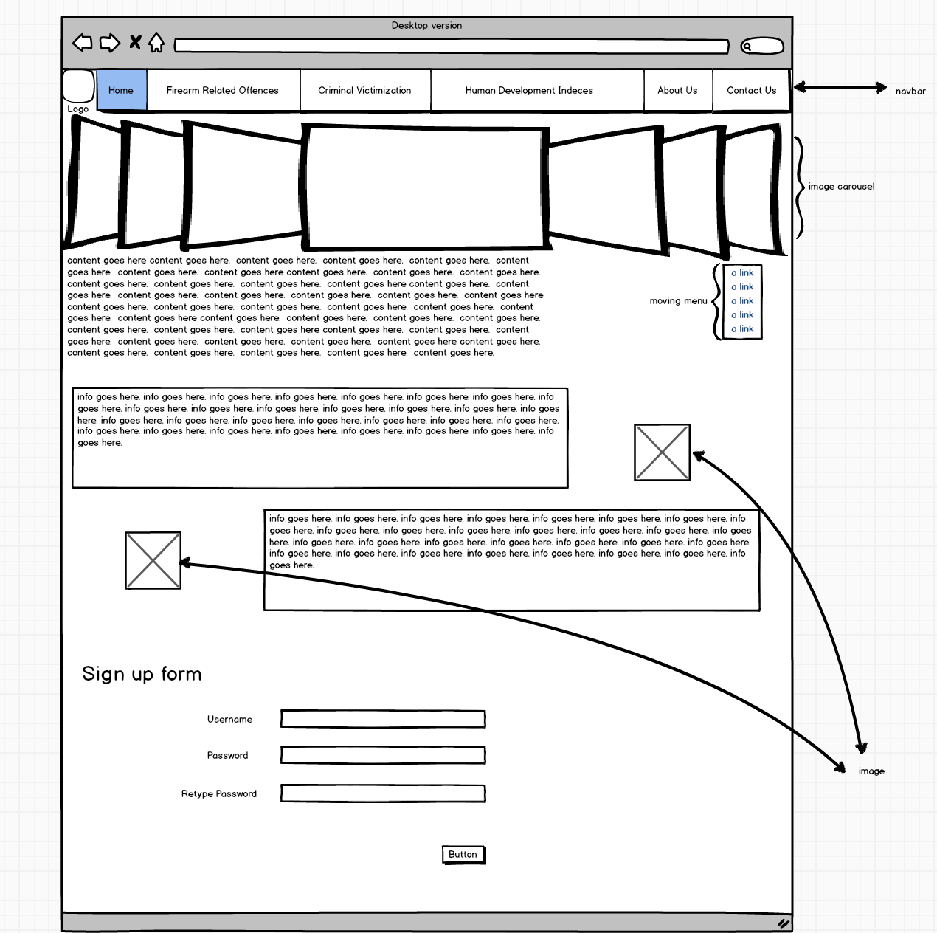

proposed view of the mobile version of the firearm statistics page

